RAJITHA PRIYANKARA

### Experience

Junior Analyst (2021 October – Present) |HCLTech Lanka

* Provide support for active directory, vulnerability assistance, and patching for large-scale enterprise systems for global clients.
* Troubleshoot and fix Microsoft software issues to ensure optimal system performance.
* Collaborate effectively with team members to ensure successful completion of projects.

Frontend developer (2021 [April - Nov]) |Infini Solution limited.

# A B O U T M E

I am a passionate and detail-oriented software engineer with expertise in frontend development using React, Vue.js, and Material UI. With a strong background in C# ASP.NET MVC, Java, and Python, I have a diverse skill set that extends to UI/UX design, database management, and Windows server administration. I am driven by a desire to stay up to date with the latest coding trends and frameworks, constantly seeking new challenges to enhance my abilities. Committed to creating scalable and efficient systems, I approach software development holistically, combining technical expertise with a creative problem- solving approach. My dedication to continuous learning and my ability to adapt to new technologies make me an asset to any development team.

# S k i l l s

## JAVA

React.js: Vue.js SCSS:

## C#: SQL:

* Built user-friendly and mobile-friendly web applications using React.js and Next.js
* Worked in an agile environment to develop frontend web solutions.
* Troubleshot CSS issues and implemented fixes to ensure optimal user experience.

Frontend developer (2023 [March - April]) |LoonsLab (Freelancing)

### Education

#### BSc (Hons) Computer Science (2022-2023)

(Staffordshire University London) {Undergraduate}

HCLTech TechBee (2021) (Linux/ Windows server administrator/ Networking)

PEARSON BTEC HND (2020-2022) - (London Metropolitan University) OVERALL GRADE – MERITE

GCE A/L (2019) & O/L (2016) - (Kingswood College, Kandy)

* Residence: 207/3, Bogashinna, Minigamuwa
* phone: +(94) 761270529
* email: [rajithatw07102@gmail.com](mailto:rajithatw07102@gmail.com)
* LinkedIn: [www.linkedin.com/in/rajitha-00-priyankara](http://www.linkedin.com/in/rajitha-00-priyankara)
* GitHub: <https://github.com/rajitha-00>
* Portfolio: <https://portfolio-new-2-0.vercel.app/>(New version under construction)

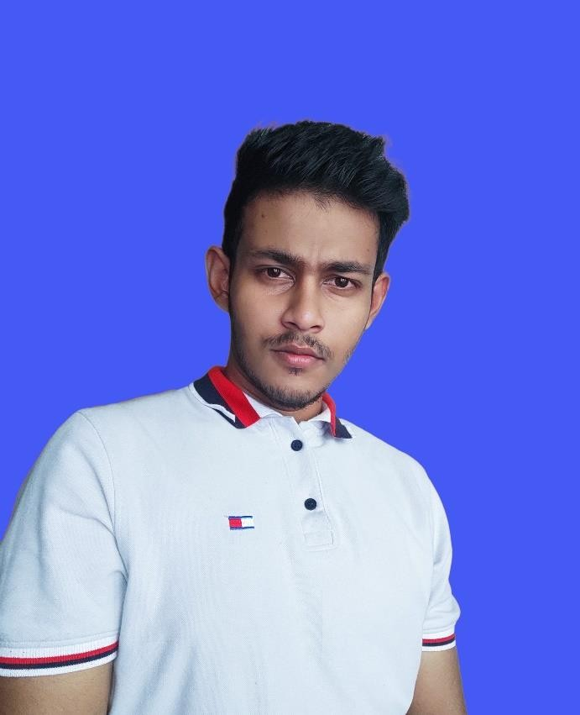

#### References: Available upon request.